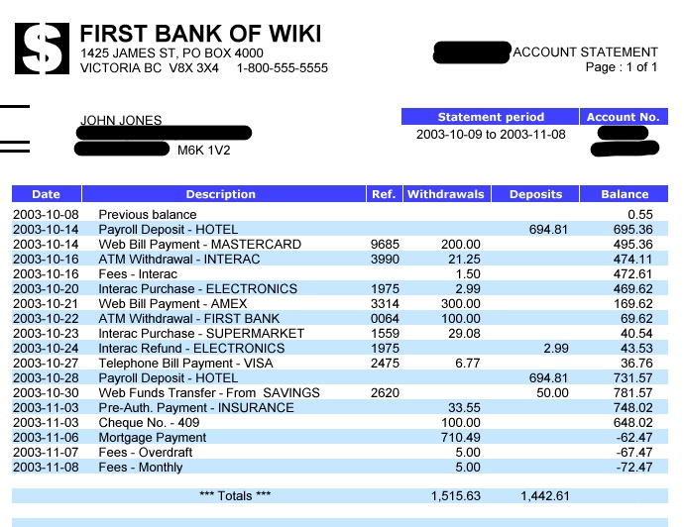

Research Proposal

Working title on the topic of _____________________: “______________________________________________________________”

Submitted by: _________________________

In this Research Proposal firstly, you should writ a justification for why it is worth researching - in other words justify its academic, practical and/or industrial importance. It would be beneficial to explain how your proposed topic goes further than previous research in the overall area.

You also include a list of the aim and objectives of the proposed research as well as the key academic ideas (theories and concepts) within the area of your proposed topic. Provide supporting references and explain how your research relates to these ideas.

It would also be a good idea to include the general research approach and specific research methods that you are intending to use.

Further, in your document, you should take time to include an explanation for why you are intending to use such an approach and set of research methods.

It is also advised to include an outline of the setting or context in which you intend to base your proposed research as well as an explanation of why you are using the setting or context.

Please use space to detail how you will gain access to the data.

There should be a section on how you intend to interpret or analyse the data, once collected.

It is important to include a tentative timeline for undertaking the proposed research and, finally, a full list of your references.
The clearer you are in your explanation of what you intend to do, the easier it is for us to assess your proposed topic and whether it is suitable for you study at the doctoral level. The proposal must not exceed 2,000 words.

[…]

