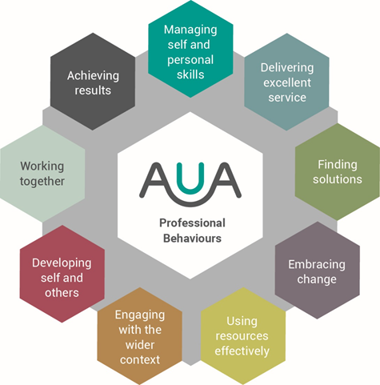

Condensed version for Talk Time discussion

This adopted framework provides a clear steer on key behaviours valued here at Oxford Brookes University. Whilst the behaviours are universal across all roles, some are very much more important in some jobs than others.

This version looks at what is important for Talk Time discussions.

Managing self and personal skills | Being aware of own behaviour and mindful of how it impacts on others, enhancing personal skills.  - having an enthusiastic and positive ‘can-do’ approach  - maintaining a healthy life balance  - being self-motivated  - accepting and demonstrating personal responsibility for health and safety and other compliance areas
Delivering excellent service | Providing the best quality service to enhance the student experience.  - delivering on our Customer First commitments  - resolving issues quickly in a courteous and purposeful manner  - being clear about where you can be flexible and where you cannot and why  - engaging positively with quality assessment processes  - delivering on what you said you would do
Finding solutions | Working enthusiastically to develop workable solutions. Identifying opportunities for innovation.  - working proactively with others  - suggesting and trying out new approaches.
Embracing change | Being open to and engaging with new ideas and ways of working. Adjusting to unfamiliar situations, shifting demands and changing roles.  - accepting that change is an integral part of life  - demonstrating a willingness to do things differently  - making suggestions for improvement.
Using resources effectively | Identifying and making the most productive use of our time.  - recognising that time is a cost and making the most of the work time accordingly.
Engaging with the wider context | Enhancing your contribution to Oxford Brookes through being clear about how own role fits into the student experience.  Embracing Oxford Brookes guiding principles  - Generosity of Spirit: We believe people flourish in a culture of respect and support, where we celebrate difference and thrive on each others' success.  - Connectedness: Our academic excellence is underpinned by a history of learning by doing. Our connections and our Oxford roots are fundamental to our students’ experiences.  - Confidence: We have confidence in our staff and students, and we know that we prepare our graduates well for a fulfilling and valuable life.  - Enterprising creativity: We’re adaptable and flexible, and consider a fresh approach in everything we do.
Developing Self and Others | Showing commitment to own ongoing development. Supporting and encouraging others to develop their knowledge, skills and behaviours to enable them to reach their full potential.  - using all situations as potential learning opportunities  - devoting time to own development  - engaging positively with Talk Time  - seeking, accepting and learning from feedback  - providing constructive feedback to colleagues at all levels
Working together | Working collaboratively with others in order to achieve objectives. Recognising and valuing the different contributions people bring to this process.  - developing productive working relationships  - interacting with others in ways that add value  - demonstrating that you value differences in people  - having a good grasp of where your responsibility ends and that of others begins
Achieving results | Consistently meeting agreed objectives and success criteria. Taking personal responsibility for getting things done.  - being clear about your role and responsibilities  - maintaining a high standard of work even when under pressure  - being flexible

