Graduate College

Professor Susan Brooks
Director of Researcher Development

All queries related to this planner should be emailed to the Research Degrees Team:
rd-enquiries@brookes.ac.uk

Personal, Professional & Career Development Planner

For part-time research students

What is the purpose of the Planner?

A research degree in the UK is accepted to be a training programme and that training, as well as being focussed on your specific research, should include training in generic, transferable and career-related skills for your personal and professional development. This should equip you better for your research and enhance your employment and career prospects after leaving Brookes, whether you choose to sat within academia / research or move into any other type of career. This Planner is provided as a tool to help you and your supervisors plan and record a programme of activities so that you can develop that portfolio of personal and professional skills. It will encourage you to identify your strengths and prioritise your professional development. It allows you to consider the skills and experiences that will enhance your career prospects and articulate your knowledge, behaviours and attributes to potential employers.

What do I need to do?

You should complete the Planner with the help of your supervisor(s). To do this, at the beginning of your research degree programme, your supervisor(s) should help you undertake a Training Needs Analysis (see page 7) where you assess what skills and competencies you already feel confident that you can demonstrate, and which ones you need to work on and develop over the course of your degree. The externally recognised Vitae Researcher Development Framework (see page 4) is a useful tool to support this analysis. There will be some activities – such as University and Faculty induction events – which are mandatory. Some activities – such as attendance at seminars or group meetings within your Department - may also be expected of you. And there will be other, project-specific or wider skills and training you may want, or need, to work on. You don’t need to do everything at once! Think about what you should focus on at different points in your programme as your skills and interests develop. Every research student is different, and the Planner is designed to accommodate the design of a training programme that is bespoke and tailored to you alone.

You should repeat the training needs analysis at the beginning of every year and, with the help of your supervisor(s) plan approximately 35 hours of activities every year (half of that expected of full time students). Your proposed programme should be approved by your Director of Studies. As you undertake your development and training activities, you should record and sign them off in your Planner. At the end of every year, that year’s training and your plans for the coming year will be reviewed as part of annual progress monitoring. At the end of your research degree, you retain the Planner as a record of your training.

What sort of things can I, and should I, include?

Each Faculty organises its own researcher training and you should receive details of this.

The Graduate College training programme can be found at https://www.brookes.ac.uk/students/research-degrees-team/current-students/graduate-college/events-and-networking/graduate-college-research-student-training/

Events organised by the University Careers Service can be found at http://www.brookes.ac.uk/students/careers/researchers/

Preparation for teaching is mandatory if you intend to undertake any teaching whilst at Brookes. Each Faculty runs discipline-specific preparation for teaching sessions and OCAED (Oxford Centre for Academic Enhancement and Development) runs an introductory teaching course for research students https://www.brookes.ac.uk/ocsld/courses/teaching-and-learning/introduction-to-learning-and-teaching-in-higher-education/ - and you must engage with both

Attendance at lab meetings, journal clubs, research group meetings, reading groups etc can be included; attendance at seminars and conferences can be included.

Self-directed or web-based learning can be included, as can training undertaken outside Brookes.

You are advised to engage with the training narrated powerpoint presentation “Your Personal, Professional & Career Development Planner, and development opportunities available to you” which was provided to you at Induction and is available on demand through the Graduate College training page https://www.brookes.ac.uk/students/research-degrees-team/current-students/graduate-college/events-and-networking/graduate-college-research-student-training/

The Researcher Development Framework (RDF)

The Researcher Development Framework represents the knowledge, behaviour and attributes of successful researchers – at all levels from undergraduate to senior research professor. It is a useful tool to enable self-assessment of strengths and competencies and identifying areas for further development and can be used to guide you and your supervisor(s) in planning your training.

For more information about the RDF see https://www.vitae.ac.uk/researchers-professional-development/about-the-vitae-researcher-development-framework

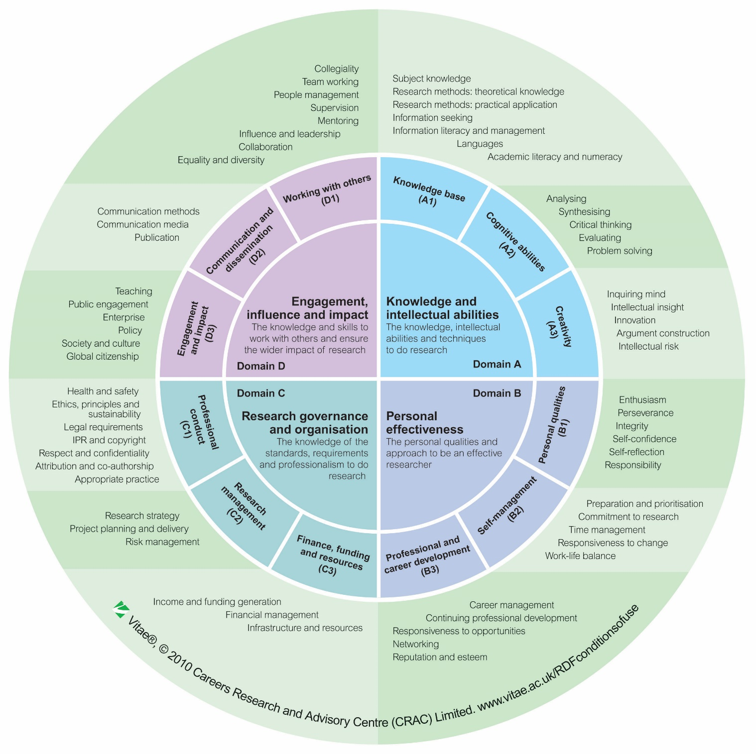

Induction

You will have been issued (electronically) with an ‘enrolment pack’ by the Graduate College when you enrolled. This contains direction to a wealth of key information about your research degree.

Both your Faculty and the Graduate College also run induction events for all new research students and you are expected to attend these events.

In addition, your supervisor(s) should ensure that you receive appropriate induction into your working environment and that you receive appropriate support and facilities. The Graduate College Student Entitlement document https://www.brookes.ac.uk/students/research-degrees-team/current-students/regulations/ clearly sets out the University’s minimum standard of basic entitlement for all areas of provision.

A checklist is provided below to support this process.

You should complete it and get it signed off by your supervisor within two weeks of your enrolment.

Facilities aware of location / access
(tick to confirm)

Desk space or equivalent

Swipecard for access to office and other relevant University spaces

Shelf / cupboard space

Lab or workshop space (if appropriate)

Computer

Project-specific software (if appropriate)

Access to printing & photocopying through Brookes managed print system

Access to stationery and supplies

Post pigeonhole

Conference funding

Other (specify)

Key staff introduced to / made aware of

Director of studies

Second supervisor(s)

Postgraduate Research Tutor(s)

Research Administrator(s)

Head of Department

General: introduced to… completed

Career development planner, RDF & training opportunities

Appropriate research seminar series

Appropriate lab / group meetings, reading groups or equivalent

Research Degrees homepage and resources

Code of practice for academic integrity (training as part of Graduate College induction / narrated powerpoint available on demand through Graduate College training page*)

Good practice for storing your research records and making a data management plan (training as part of Graduate College induction / narrated powerpoint available on demand through Graduate College training page*)

Library and information resources

Computer services and support

General University facilities eg sports centre, etc

Discussed and agreed frequency of supervisory meetings

*https://www.brookes.ac.uk/students/research-degrees-team/current-students/graduate-college/events-and-networking/graduate-college-research-student-training/

Supervisor signature ………………………………………………………………………………

Print name ………………………………………………………………………………………….

Date …………………………………..

Student signature ………………………………………………………………………………….

Print name …………………………………………………………………………………………

Date …………………………………..
Year 1 training needs analysis & training proposal

Student name…………………………….

Use this form in conjunction with the researcher development framework on page 4

Skills domain & sub-domains  (skills to be developed) | Outline appropriate action or training.  Include specific reference to Faculty, Graduate College, University or other training, including self directed learning | Approx no. hrs  (the total for the year should be 35 hrs) | Which RDF ‘descriptors’ (listed in the outer circle of the RDF diagram) will the action or training specifically address?
A Knowledge & intellectual abilities

A1 knowledge base

A2 cognitive abilities

A3 creativity

B Personal effectiveness

B1 personal qualities

B2 self management

B3 professional & career development

C research governance & organisation

C1 professional conduct

C2 research management

C3 finance funding & resources

D engagement, influence & impact

D1 working with others

D2 communication & dissemination

D3 engagement & impact

Agreed by supervisor (signed) ……………………………………………….. date
Record of Year 1 training completed (a copy should be submitted with your first year report)

Student name…………………………….

Use this form in conjunction with the researcher development framework on page 4

Skills domain & sub-domains  (skills to be developed) | Training undertaken / date | Hours  (the total for the year should be 35 hrs) | Student signature
A Knowledge & intellectual abilities

A1 knowledge base

A2 cognitive abilities

A3 creativity

B Personal effectiveness

B1 personal qualities

B2 self management

B3 professional & career development

C research governance & organisation

C1 professional conduct

C2 research management

C3 finance funding & resources

D engagement, influence & impact

D1 working with others

D2 communication & dissemination

D3 engagement & impact

Approved by supervisor (signed) ……………………………………………….. date

Approved by Postgraduate Research Tutor (signed) …………………………. Date
Year 2 training needs analysis & training proposal

Student name…………………………….

Use this form in conjunction with the researcher development framework on page 4

Skills domain & sub-domains  (skills to be developed) | Outline appropriate action or training.  Include specific reference to Faculty, Graduate College, University or other training, including self directed learning | Approx no. hrs  (the total for the year should be 35 hrs) | Which RDF ‘descriptors’ (listed in the outer circle of the RDF diagram) will the action or training specifically address?
A Knowledge & intellectual abilities

A1 knowledge base

A2 cognitive abilities

A3 creativity

B Personal effectiveness

B1 personal qualities

B2 self management

B3 professional & career development

C research governance & organisation

C1 professional conduct

C2 research management

C3 finance funding & resources

D engagement, influence & impact

D1 working with others

D2 communication & dissemination

D3 engagement & impact

Agreed by supervisor (signed) ……………………………………………….. date
Record of Year 2 training completed (a copy should be submitted with your second year report)

Student name…………………………….

Use this form in conjunction with the researcher development framework on page 4

Skills domain & sub-domains  (skills to be developed) | Training undertaken / date | Hours  (the total for the year should be 35 hrs) | Student signature
A Knowledge & intellectual abilities

A1 knowledge base

A2 cognitive abilities

A3 creativity

B Personal effectiveness

B1 personal qualities

B2 self management

B3 professional & career development

C research governance & organisation

C1 professional conduct

C2 research management

C3 finance funding & resources

D engagement, influence & impact

D1 working with others

D2 communication & dissemination

D3 engagement & impact

Approved by supervisor (signed) ……………………………………………….. date

Approved by Postgraduate Research Tutor (signed) …………………………. date

Year 3 training needs analysis & training proposal

Student name…………………………….

Use this form in conjunction with the researcher development framework on page 4

Skills domain & sub-domains  (skills to be developed) | Outline appropriate action or training.  Include specific reference to Faculty, Graduate College, University or other training, including self directed learning | Approx no. hrs  (the total for the year should be 35 hrs) | Which RDF ‘descriptors’ (listed in the outer circle of the RDF diagram) will the action or training specifically address?
A Knowledge & intellectual abilities

A1 knowledge base

A2 cognitive abilities

A3 creativity

B Personal effectiveness

B1 personal qualities

B2 self management

B3 professional & career development

C research governance & organisation

C1 professional conduct

C2 research management

C3 finance funding & resources

D engagement, influence & impact

D1 working with others

D2 communication & dissemination

D3 engagement & impact

Agreed by supervisor (signed) ……………………………………………….. date
Record of Year 3 training completed (a copy should be submitted with your third year report)

Student name…………………………….

Use this form in conjunction with the researcher development framework on page 4

Skills domain & sub-domains  (skills to be developed) | Training undertaken / date | Hours  (the total for the year should be 35 hrs) | Student signature
A Knowledge & intellectual abilities

A1 knowledge base

A2 cognitive abilities

A3 creativity

B Personal
effectiveness

B1 personal qualities

B2 self management

B3 professional & career development

C research governance & organisation

C1 professional conduct

C2 research management

C3 finance funding & resources

D engagement, influence & impact

D1 working with others

D2 communication & dissemination

D3 engagement & impact

Approved by supervisor (signed) ……………………………………………….. date

Approved by Postgraduate Research Tutor (signed) …………………………. date
Year 4 training needs analysis & training proposal

Student name…………………………….

Use this form in conjunction with the researcher development framework on page 4

Skills domain & sub-domains  (skills to be developed) | Outline appropriate action or training.  Include specific reference to Faculty, Graduate College, University or other training, including self directed learning | Approx no. hrs  (the total for the year should be 35 hrs) | Which RDF ‘descriptors’ (listed in the outer circle of the RDF diagram) will the action or training specifically address?
A Knowledge & intellectual abilities

A1 knowledge base

A2 cognitive abilities

A3 creativity

B Personal effectiveness

B1 personal qualities

B2 self management

B3 professional & career development

C research governance & organisation

C1 professional conduct

C2 research management

C3 finance funding & resources

D engagement, influence & impact

D1 working with others

D2 communication & dissemination

D3 engagement & impact

Agreed by supervisor (signed) ……………………………………………….. date

Record of Year 4 training completed (a copy should be submitted with your fourth year report)

Student name…………………………….

Use this form in conjunction with the researcher development framework on page 4

Skills domain & sub-domains  (skills to be developed) | Training undertaken / date | Hours  (the total for the year should be 35 hrs) | Student signature
A Knowledge & intellectual abilities

A1 knowledge base

A2 cognitive abilities

A3 creativity

B Personal
effectiveness

B1 personal qualities

B2 self management

B3 professional & career development

C research governance & organisation

C1 professional conduct

C2 research management

C3 finance funding & resources

D engagement, influence & impact

D1 working with others

D2 communication & dissemination

D3 engagement & impact

Approved by supervisor (signed) ……………………………………………….. date

Approved by Postgraduate Research Tutor (signed) …………………………. date
Year 5 training needs analysis & training proposal

Student name…………………………….

Use this form in conjunction with the researcher development framework on page 4

Skills domain & sub-domains  (skills to be developed) | Outline appropriate action or training.  Include specific reference to Faculty, Graduate College, University or other training, including self directed learning | Approx no. hrs  (the total for the year should be 35 hrs) | Which RDF ‘descriptors’ (listed in the outer circle of the RDF diagram) will the action or training specifically address?
A Knowledge & intellectual abilities

A1 knowledge base

A2 cognitive abilities

A3 creativity

B Personal effectiveness

B1 personal qualities

B2 self management

B3 professional & career development

C research governance & organisation

C1 professional conduct

C2 research management

C3 finance funding & resources

D engagement, influence & impact

D1 working with others

D2 communication & dissemination

D3 engagement & impact

Agreed by supervisor (signed) ……………………………………………….. date

Record of Year 5 training completed (a copy should be submitted with your fifth year report)

Student name…………………………….

Use this form in conjunction with the researcher development framework on page 4

Skills domain & sub-domains  (skills to be developed) | Training undertaken / date | Hours  (the total for the year should be 35 hrs) | Student signature
A Knowledge & intellectual abilities

A1 knowledge base

A2 cognitive abilities

A3 creativity

B Personal
effectiveness

B1 personal qualities

B2 self management

B3 professional & career development

C research governance & organisation

C1 professional conduct

C2 research management

C3 finance funding & resources

D engagement, influence & impact

D1 working with others

D2 communication & dissemination

D3 engagement & impact

Approved by supervisor (signed) ……………………………………………….. date

Approved by Postgraduate Research Tutor (signed) …………………………. Dat
If your programme extends for more than five years, you can copy and add extra pages; if your programme is less than five years long, you can delete pages, as appropriate

Planner last updated July 2022
Susan Brooks, Director of researcher Development

