A User Guide to File Encryption

Introduction
File encryption is increasingly considered as a robust means of protecting sensitive and/or confidential documents whether or not they are to be shared. This document provides guidance on installing and using two University approved encryption tools for use on Windows and MacOs computers: 7-zip and Keka. Linux users can use the File Roller application (with p7zip-full installed) or try one of the 7-zip ports available on the 7-zip website.

The maximum file size for encryption is 16 Exabytes (EB), almost limitless for most purposes. There should be no geographical restrictions on downloading the software.

When sharing documents, do not give out the encryption password using the same email account from which you are sending the encrypted file. For security either phone the recipient with the password or send an SMS to a trusted mobile number.

Once a file is shared, the recipient must have the same encryption software to be able to view, amend and re-encrypt the file.

The Brookes IT Service Desk will be happy to assist with installation and use of these encryption tools however it is important to note that they will not be able to restore access to files should you forget the password.

Windows - Installing 7-zip

- You will need local administrator privileges to proceed with installation on a Brookes supplied device, if you do not have local admin access please contact the Brookes IT Service desk at: https://service.brookes.ac.uk/brookes . Go to: IT Services Requests > Software Ordering > IT Services Software Request > Software Requests (and tick the 'software not in list' checkbox) alternatively call on ext. 3311.
If you are installing onto your own private machine, follow from step 2.

- Go to http://www.7-zip.org/download.html
- Select the appropriate version for the laptop or computer you are using, most modern Windows devices are 64-bit.
To check which version you require go to Control Panel > System > System type.

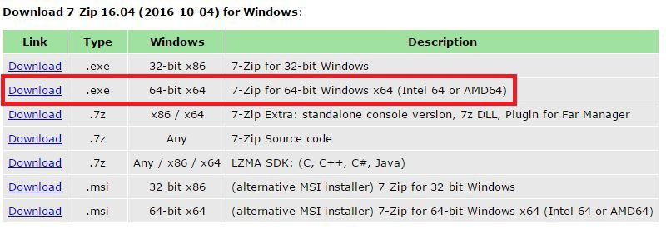

- Open the downloaded .exe file and follow the instructions.

Windows - Using 7-zip to encrypt a file or files

- To select a file to encrypt, use ‘My Computer’ or ‘Windows Explorer’ to bring up the folder / file and select by clicking the required file/folder:
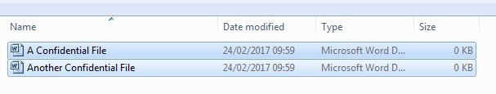
- Right-click on the selected files and choose “7-zip” > “Add to archive”:

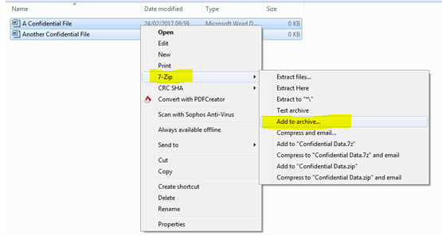

Choose a name for the encrypted file and select the following recommended options:
- Archive format = 7z
- Password that meets OBU requirements (min. 8 characters, mixture of upper and lower case characters, numbers and special characters)
- Encryption method = AES-256 and Encrypt filenames = Enabled
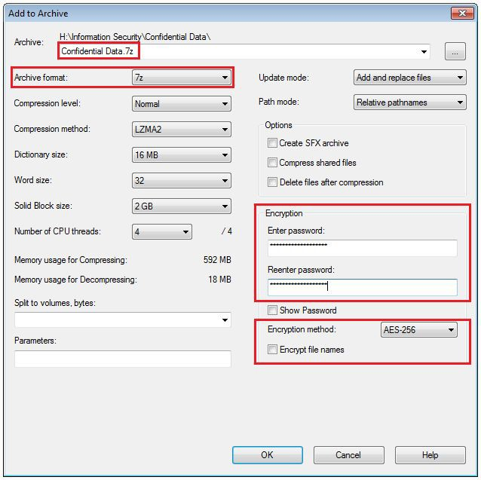

Click “OK” and an encrypted 7-zip archive file should appear in the same folder as your original files

MacOS - Installing Keka

You will need local administrator privileges to proceed with installation on a Brookes supplied device, if you do not have local admin access please contact the Brookes IT Service desk at https://service.brookes.ac.uk/brookes . Or call on ext. 3311.
Go to http://www.kekaosx.com/en/
Click “Download Keka x.x.x” and follow instructions:

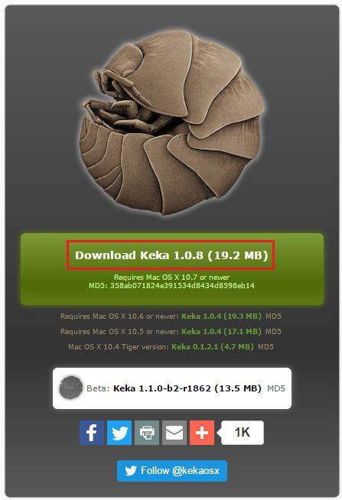

MacOS - Using Keka to encrypt a file or files

Open Keka, select 7z and enter a password that meets OBU requirements (min. 8 characters, mixture of upper and lower case characters, numbers and special characters).

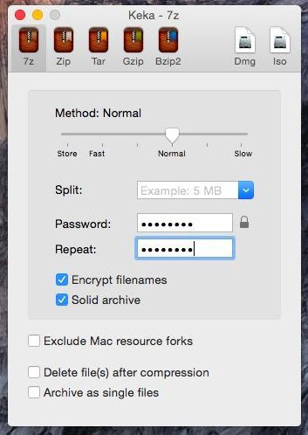

Drag and drop one or more files you want to compress onto the Keka window and they’ll be compressed into an encrypted 7z file with the password you provided:

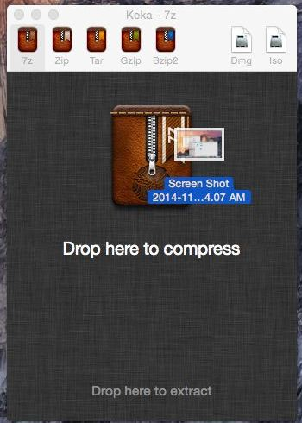

Further Questions
If you have any further queries regarding encryption or other aspects of information security please contact the Brookes IT Services Information Management team at: info.sec@brookes.ac.uk

Version 1.4 – March 2017

