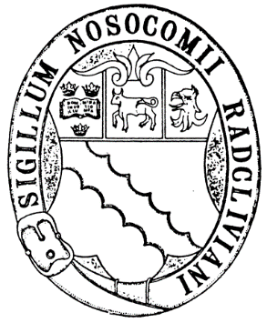

Radcliffe Guild of Nurses Application for Membership

Membership of the Guild, which was founded in 1925, is open to all nurses who have been trained in Oxford to become a registered nurse or graduated in any pre-registration branch of nursing or midwifery from Oxford Brookes University.

The cost of membership is a one-off payment of £20.

Membership enables you to:

1 Apply for a Bursary from the Anne Harrold Radcliffe Guild of Nurses Charitable Trust to either undertake a project or further your studies and enhance nursing and midwifery care.

2 Attend an annual reunion and annual general meeting in June each year.

3 The annual magazine is posted in March, and costs of £6 per annum. Payment is by cheque or preferably by standing order in January each year.

Please make cheques for £6 payable to Radcliffe Guild of Nurses or direct debit each January to Radcliffe Guild of Nurses. Account number 67841872 sort code 60-16-07

4. Nurses and midwives who qualified in Oxford or through Oxford Brookes University are eligible to become full members with voting rights.

5. Nurses who have worked in Oxford for three years are eligible to become honorary members.

6. Those who started but didn’t complete their training can become associate members, but do not have voting rights.

I wish to enrol as a member of the Radcliffe Guild of Nurses and enclose £20 for my life membership
Full Name (including maiden name if appropriate)

Date of Birth

Type of Member Full or Associate

Month and Year of entry to training

Date of Registration with the NMC

Address and post code

Telephone number | Mobile:  Home:
Email

Signed and date

By signing this form, I agree for my details to be kept on a secure database for use only by the Radcliffe Guild of Nurses

Badges and replacement badges are available at a cost of £15. If you wish to receive a badge, please complete the form below.

If you wish to receive the annual magazine the cost is £6 payable each January and it will be posted to you in March. Please make cheques for £6 payable to Radcliffe Guild of Nurses or direct debit each January to Radcliffe Guild of Nurses. Account number 67841872 sort code 60-16-07

I wish to receive a Radcliffe Guild badge  Yes / No | Address:
I wish to receive the annual magazine. Yes / No | Address:

Please return this form by email to - radcliffeguild@gmail.com

OR by post to Mrs J Walters, 13 Gessey Close, Long Hanborough, Oxon OX29 8FR

If paying by cheque please send to the address above.

Data Protection
The Data Protection Act 2018. We advise you that we keep all members details on a data base. We will not release your details to anyone before we have contacted you to ask permission. Please see our Data Protection Policy. Form last reviewed November 2020.

