Student Submission of Application for Registration or Transfer

This is a guide for research students who would like to submit their application for Registration or Transfer to the HESS or S&T Sub-Committees. Applications should be submitted for consideration 2 weeks before the relevant Sub-Committee meeting.

- Before submitting your application please ensure that it has been reviewed by your DOS and your PGRT. Guidance Notes for completing the RDC-R form should be followed closely. The Faculty staff will need sufficient time to review your application before the submission deadline.

- You should always download the most up to date version of the RDC-R or RDC-T form from the Research Degrees Team website.

- This should be completed with support from your Director of Studies and the submission should be within the timeframe notes in the Research Degrees Policy and Procedures Handbook, section 5. Once it is complete and ready to submit to the Sub-Committee you will need to submit the application via your Student Information.

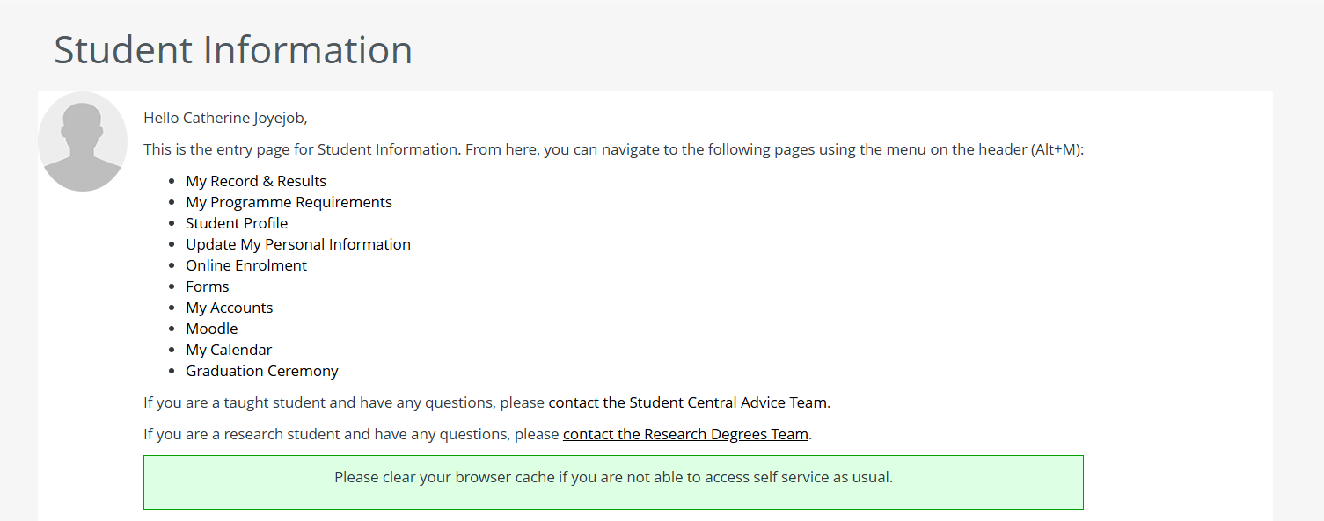

- Go to Forms, Register or Transfer Request and choose the relevant application.

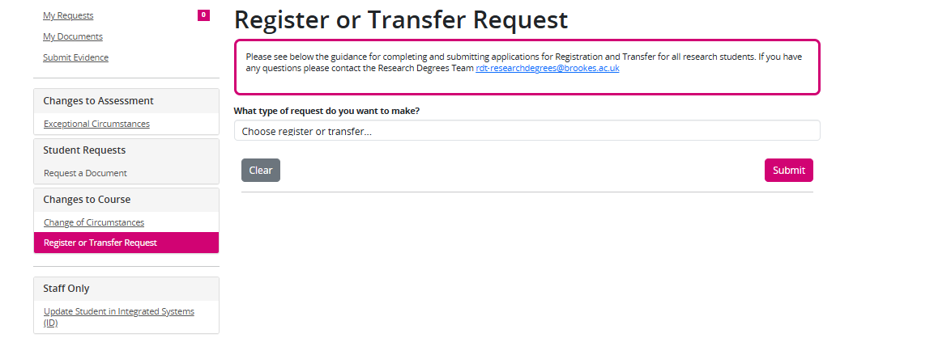
- Once your form is completed and ready to upload you should attach the form and any other additional evidence (for example, your AI certificate, ethics approval letters, letters of collaboration, supervisor CVs) via the portal.

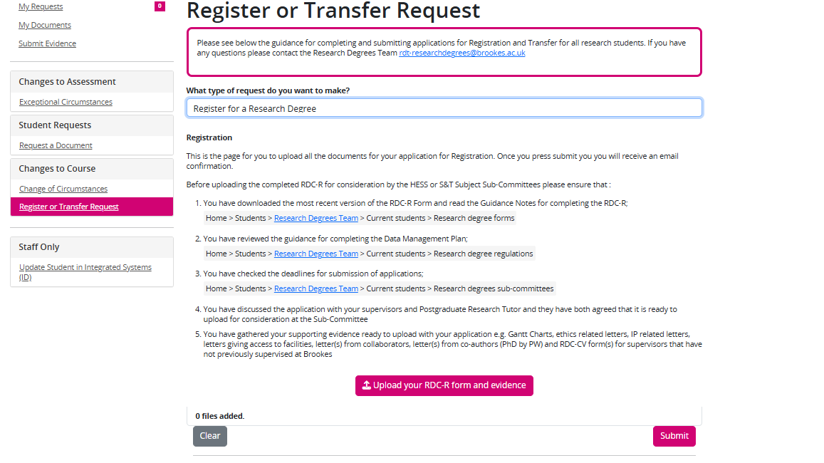

- Once all the documents have been uploaded press SUBMIT.

- You will receive an email confirming submission and this will contain a unique ID. You should quote this ID if you need to contact the Research Degrees Team about the application.

- Once you have submitted your application you will be able to review the status of this via your Student Information under ‘My Requests’.

- Once the application has been submitted it will be checked by RDT and then sent for formal approval to your DOS and PGRT. If there is anything missing or any details that need correcting this may be returned to you with notes. You would then be required to resubmit the corrected file.

- When all approvals are complete the application will go forward to the Sub-Committee and you will receive feedback after the meeting. Formal feedback takes up to 7-10 working days to be sent but you should receive an informal update from your PGRT who will have represented your application at the meeting.

