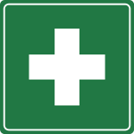
FIRST AID

The location of your nearest first aider

Name | Room Number | Phone

If you are unable to get hold a first aider contact:

08:00 – 19:00 JHBB Reception x 8200 or 09:00 – 17:00 Switchboard x 100

After hours contact x 3060 (01865 483060)

