Brookes Framework for Ensuring Digitally Enabled Programmes for Semester One of 2020/21 (Version 2)

Preamble (for Academic Covid purposes)

On 21.5.20 the Sustainable Teaching Online Working Group considered an earlier draft of this document. Following feedback at the meeting and subsequently, a revised document is now presented to Academic Covid on 29.5.20.

When formally approved in this or a further amended form, the intention is that the Framework and related guides should be incorporated into an updated version of the OCSLD Moving Teaching and Assessment Online intranet site. This intranet site will thus remain the “One Stop Shop” widely requested by staff to help manage current and future transitions.

Introduction

The Brookes Framework for Ensuring Digitally Enabled Programmes outlines the steps programme and module teams need to take to plan and prepare for next academic year. The objective is programmes and modules across the university in a position to combine the best of synchronous (oncampus or online) and asynchronous delivery, in all the potential scenarios that might affect the physical location and working/learning environments of staff or students as the COVID19 pandemic evolves. The framework outlines the processes and stages for reviewing semester 1 teaching over the coming months at programme and module level to ensure a coherent, accessible and inclusive student learning experience next year. The emphasis on accessibility and inclusion throughout is to ensure adherence to Guiding Principle 3 below and to our Public Sector Equality Duty. The intended outcome of the Brookes Digitally Enabled Programmes Framework is that all learners experience an equivalent level of academic challenge/rigour and support (appropriate to the disciplinary context) as would have been their expectation in earlier times.

Guiding Principles

The Guiding Principles adopted for the recent transition to online learning remain in place:

1/ We need to keep it simple, but do it well
2/ We need to focus on the delivery of programme level learning outcomes
3/ We need our delivery and related activity to be of good quality and to be inclusive and
accessible to all students
4/ We need to ensure that we align what we do to the strategic priorities outlined in the
‘ Education and Enterprise ’ pillar of the 2035 strategy.
5/ We need to ensure colleagues have time dedicated to preparation and delivery
6/ We need to base plans on the likelihood of limited capacity for investment in
infrastructure/kit/equipment

Synchronous and asynchronous learning
These are two terms used throughout this guidance.
By synchronous we mean working or learning together at the same time. In oncampus learning this might refer to a lecture in a lecture theatre, labwork or workshop in which staff and students are in the same room at the same time. In the online learning world, chat rooms and online “live” seminars are examples of synchronous communication. Learning from synchronous communication is enhanced because real-time conversations allow people to explore topics, whether through writing or talking.
Asynchronous learning involves communication exchanges with a time lag, whether in written or spoken form. Uploading learning tasks to a moodle site for completion at a future time, discussion forums and email are examples of asynchronous communication. This time lag in communication can help students internalise information by giving them time to research ideas or extra thinking time.

The four Dimensions of the Framework
The Framework comprises four inter-related dimensions for programme teams to work through from June 2020 onwards either working by level (4/5/6/7) or across levels. The framework serves as a ‘one-stop shop’ for teams, with links off to relevant web pages and guides.

The four dimensions are:

- Summer Timeline showing design stages and sign-off points
- Programme Study Maps (by level) for use by staff and students, and Student Study Plans (at modular level) for students.
- Programme and Module level Teaching and Learning Requirements and underpinning Features Checklists (ensuring accessibility and inclusion).
- Practical (“how to”) guides showing how (and why) to implement the Requirements and Features and drawing on key lessons learnt from the recent pivot to online as well as from extant good practice across OBU.

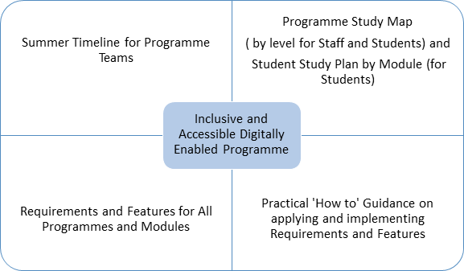

Summer Timeline for Programme Teams
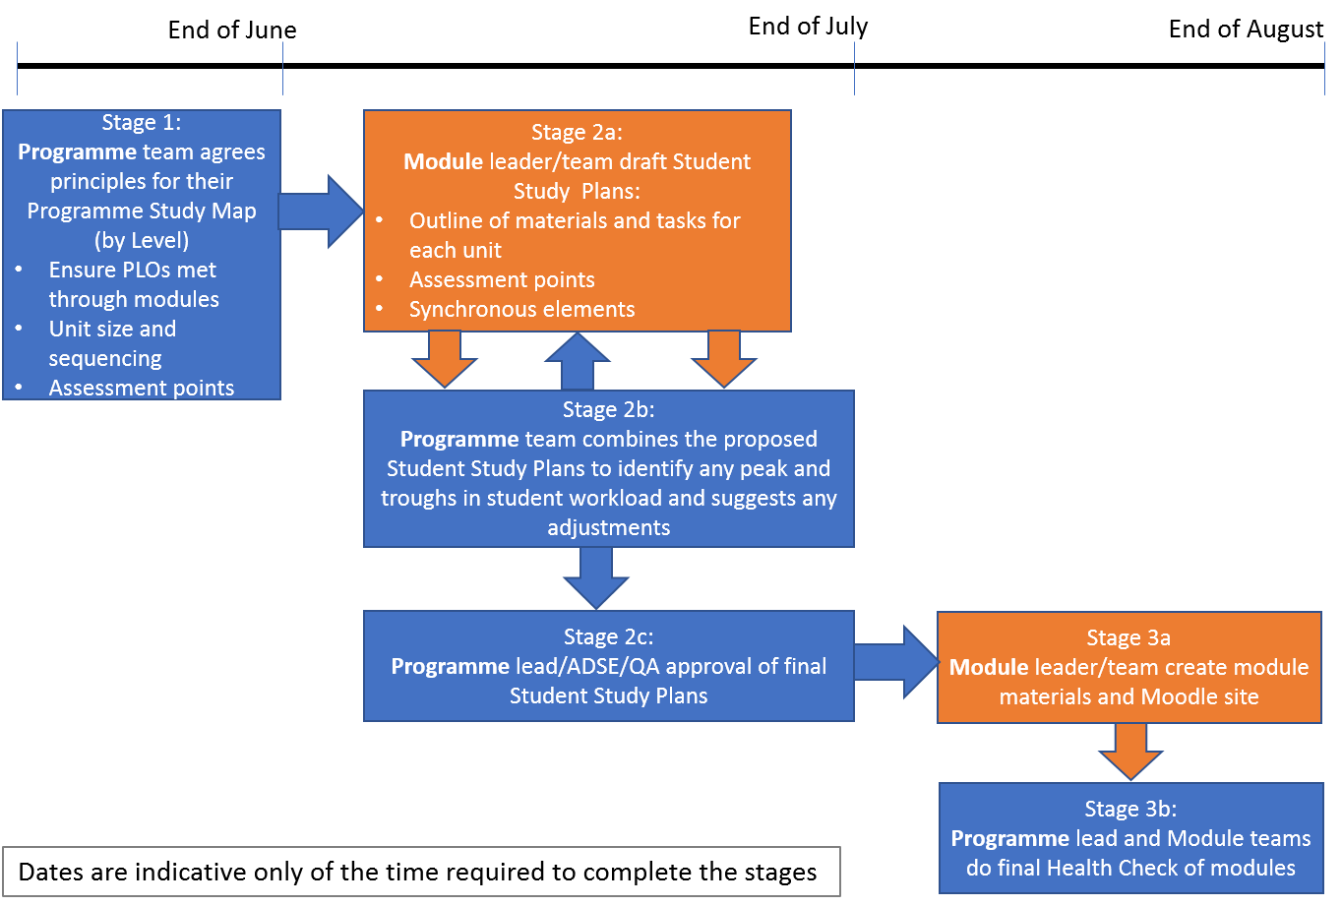

Programme Study Maps (by level) for staff and students, and Student Study Plans for students.
The Programme Study Maps (PSMs) and module-level Student Study Plan (SSP) shown below are intended as indicative not prescriptive exemplars. If teams already have proformas in place that serve the same purposes please continue to use them.

Units of Study - both PSMs and SSPs encourage attention to a Unit of Study within a module rather than a Unit of Time. While every module necessarily has a start and an end date, programme and module teams are advised to plan for students needing to take part in learning in flexible, unpredictable ways (e.g because of quarantining or web access issues). Plans too tightly focused on Units of Time especially units as short as a week potentially create inequalities in access and outcomes.

Example of a Semester One UG Programme Study Map for Level 4 (all modules compulsory)
Staff would use the Programme Study Map to align synchronous components, manage student workload and stagger assessments. Students would use the Programme Study Map to identify the overall expected pattern of demands on their time over the course of the semester.

While the Programme Study Maps are designed around the formally approved 150 study hours per 15 credit module, programme teams should also be cognisant of what might reasonably be expected in an “average working week” during the 12 taught weeks of any module.
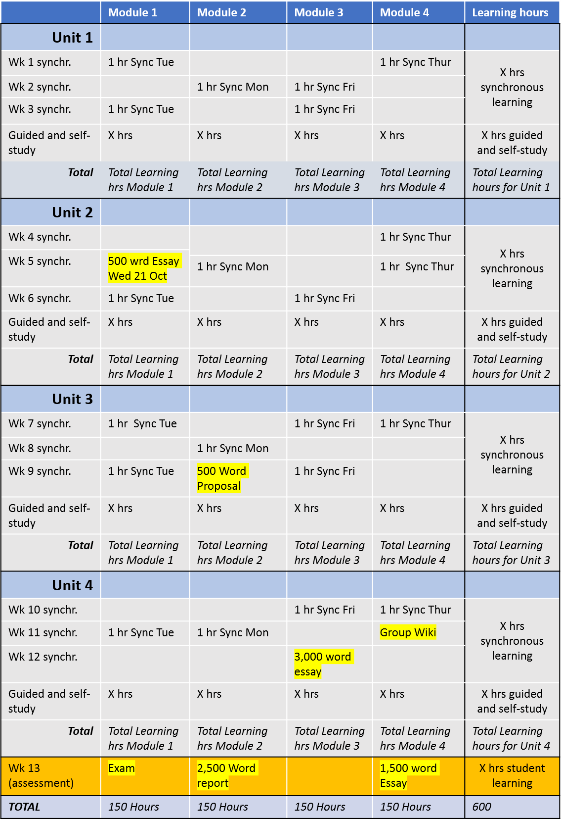

Example of a Semester One UG Programme Study Map for Level 5/6 (with electives)
Staff would use the Programme Study Map to align synchronous components, manage student workload and stagger assessments. Students would use the Programme Study Map to identify the overall expected pattern of demands on their time over the course of the semester and could delete the elective columns not applying to them.
While the Programme Study Maps are designed around the formally approved 150 study hours per 15 credit module, programme teams should also be cognisant of what might reasonably be expected in an “average working week” during the 12 taught weeks of any module.
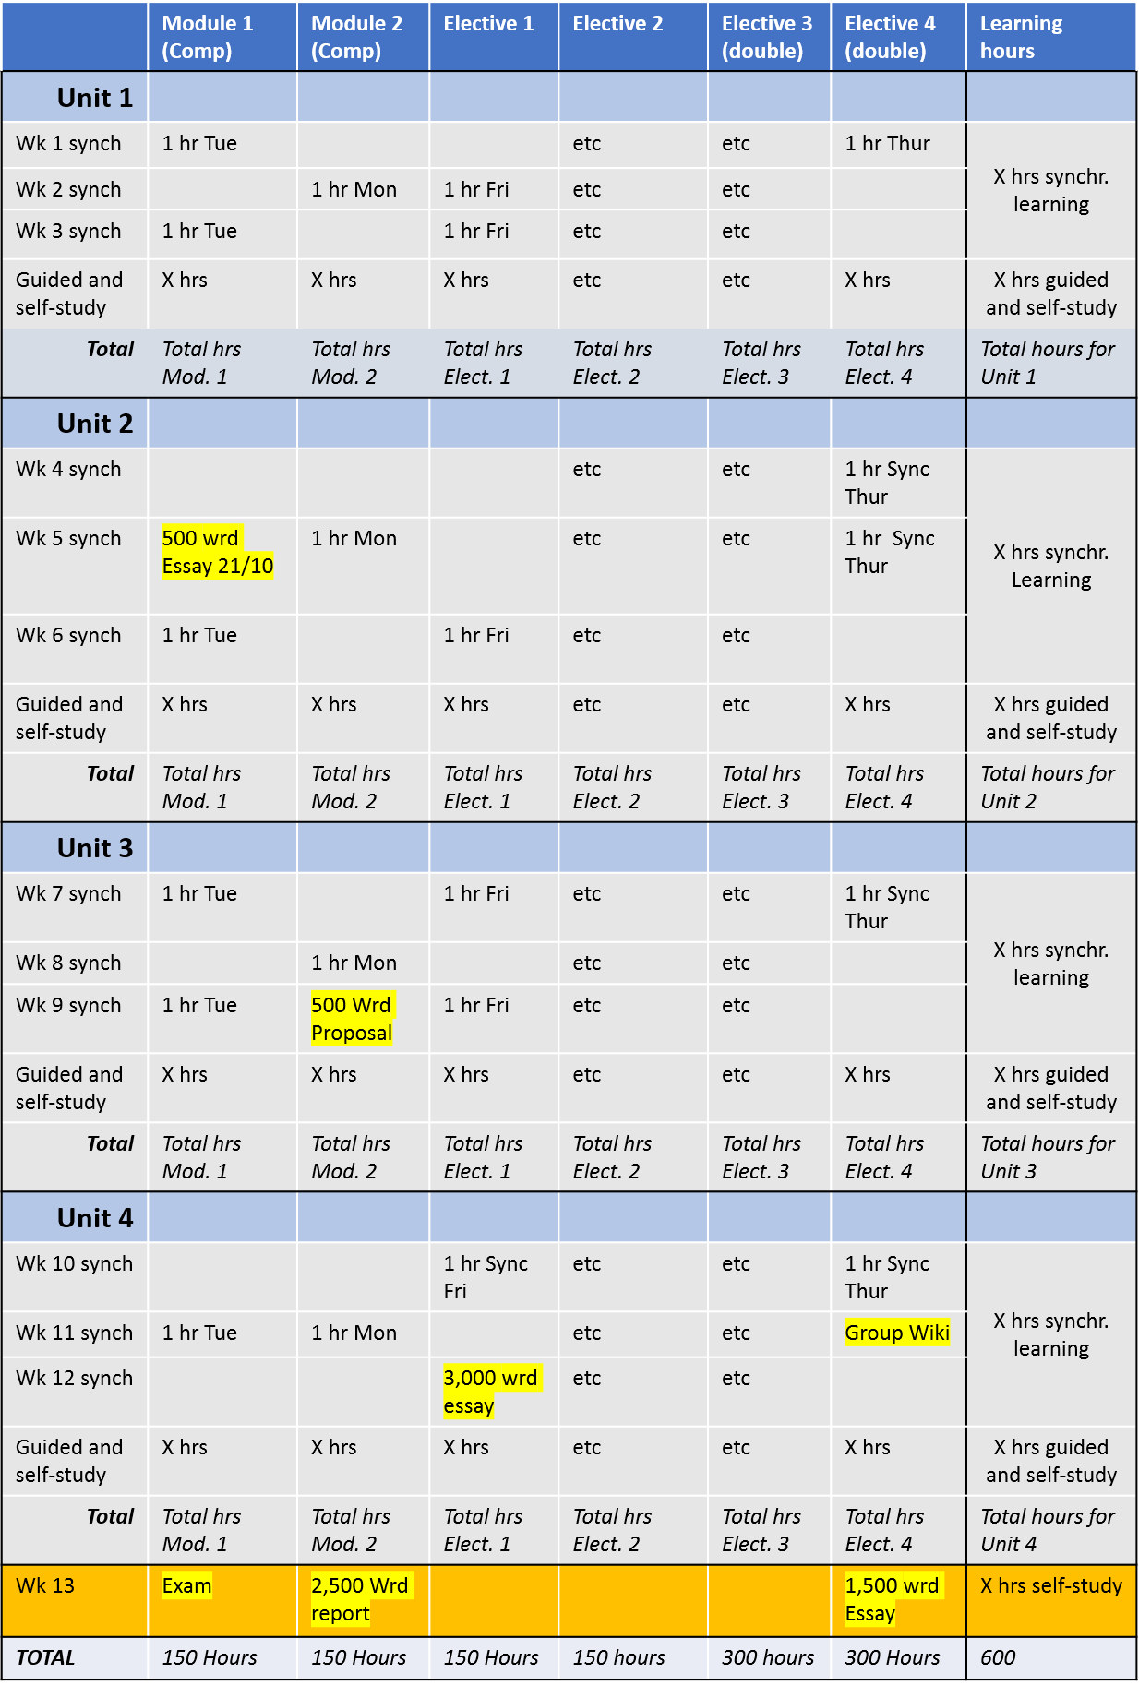

Example Student Study Plan for one Module

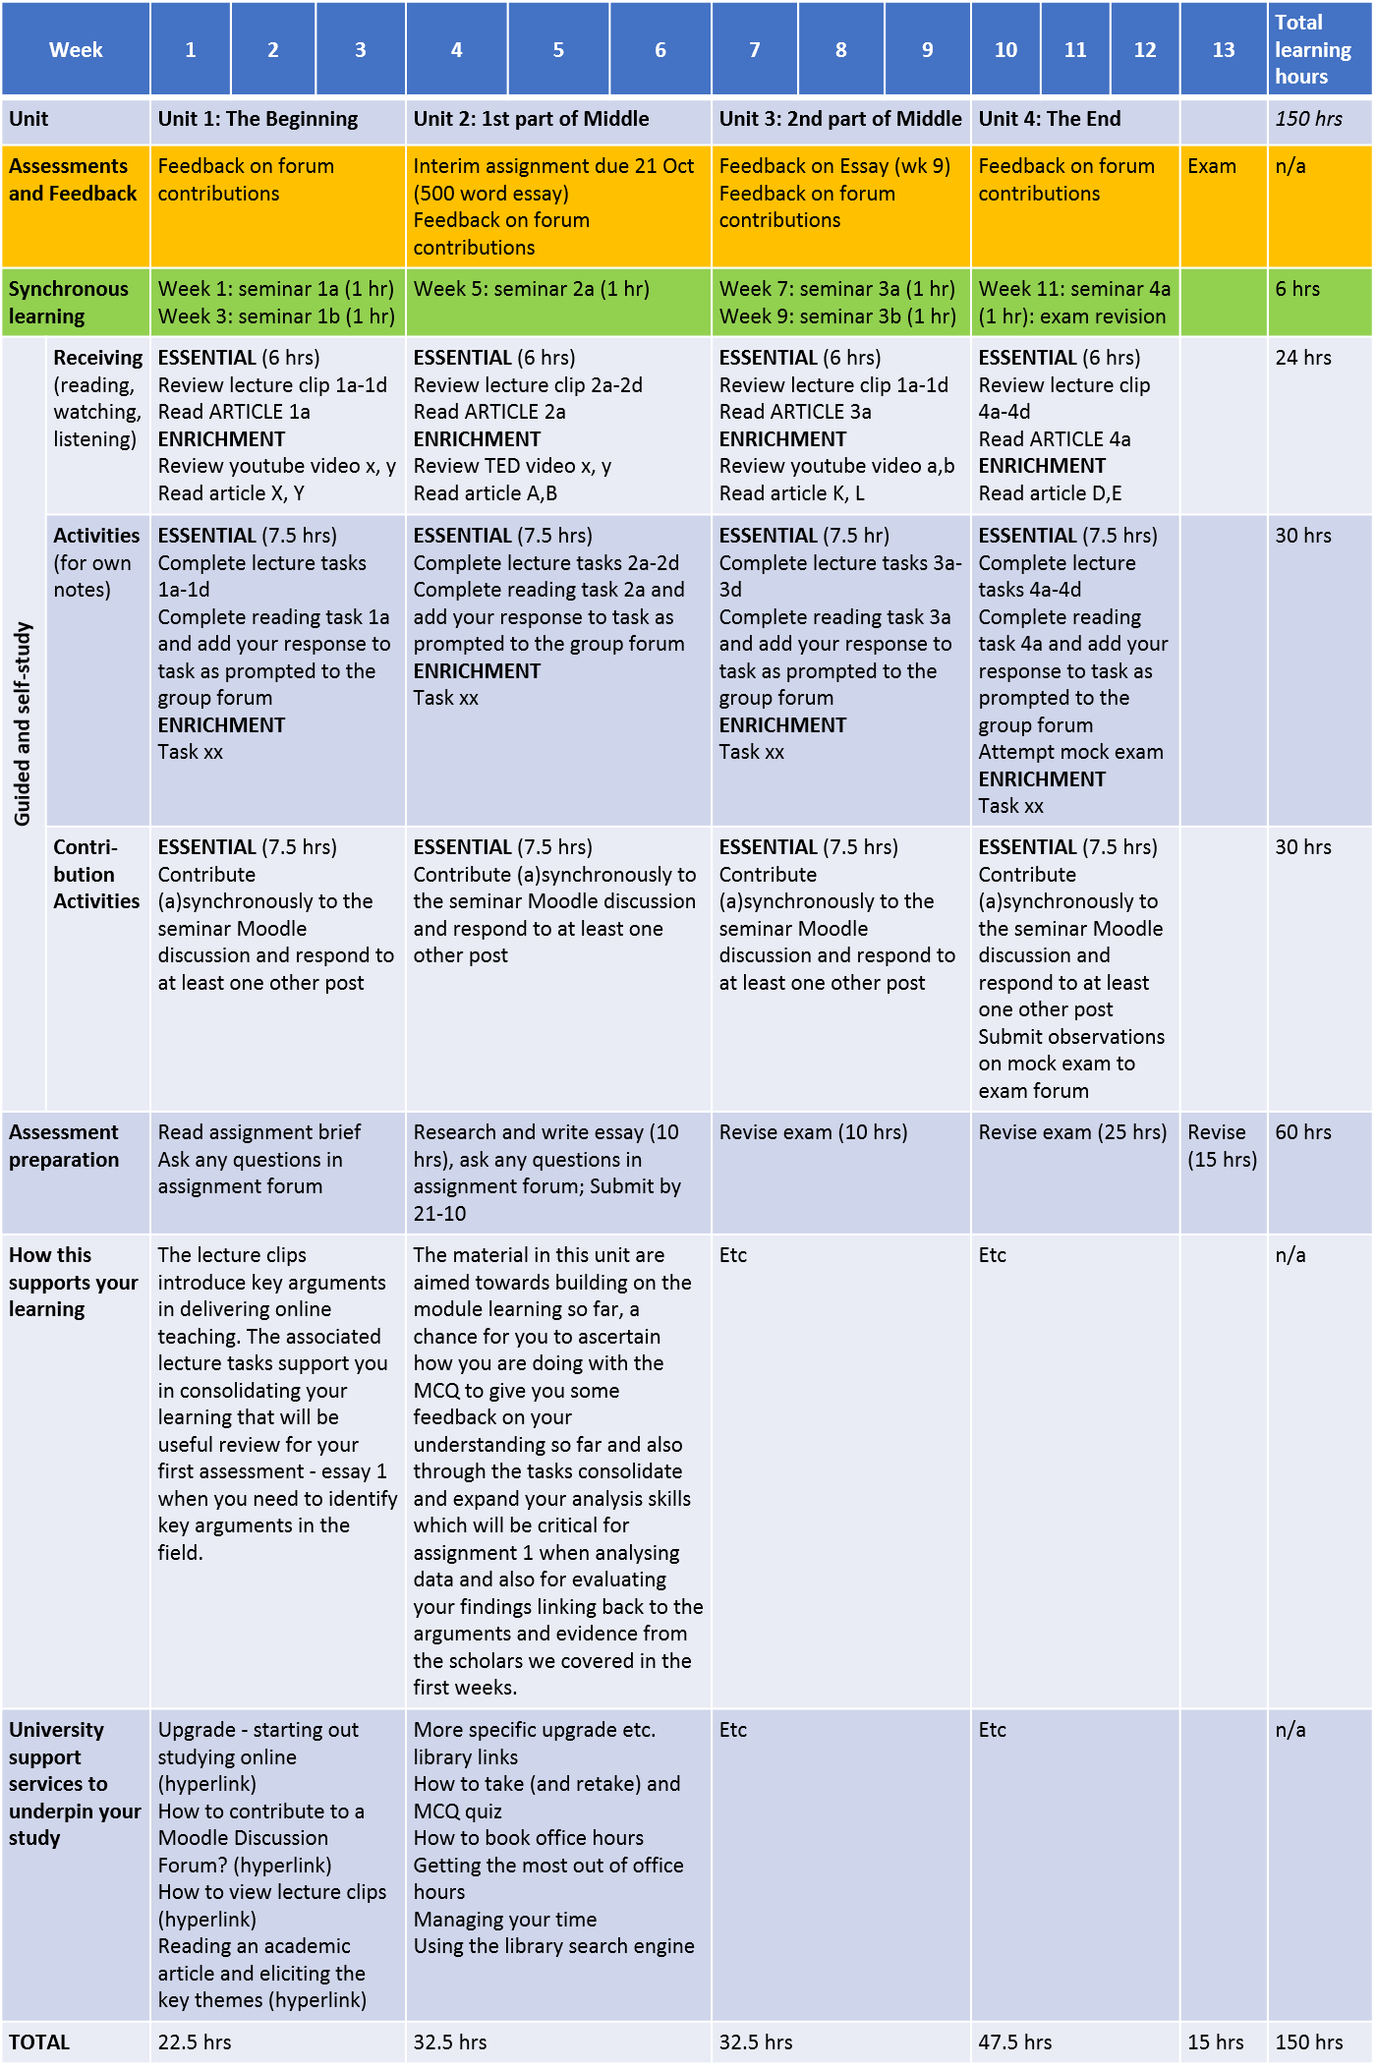

3. Features and Requirements of Digitally Enabled Programmes

For all programmes the following Features will need to be present to ensure that the Digitally Enabled programme is accessible and inclusive for all learners. In order to realise these Features, a number of specific Requirements apply at programme and module levels.

Features (based on Nordmann et al paper, Rules, 2, 3, 4, 5, 6, 7, 8, 9 and 10)

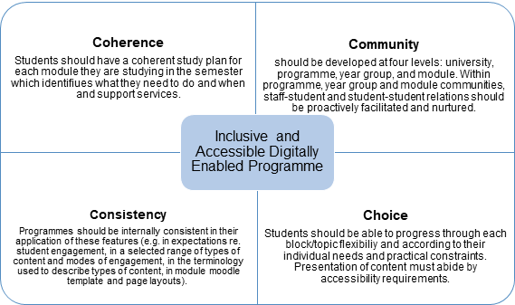

Requirements Checklists

Programme and Module teams can use the checklists below to ensure inclusive and accessible digitally enabled programmes. We recommend they are used through all the stages on the timeline.

Most teams will already have many of the elements below in place. What these lists aim to do is draw together in one place a set of practices that both Brookes experience and/or the wider literature suggest will enable inclusive and accessible programmes and a sense of student belonging within programmes.

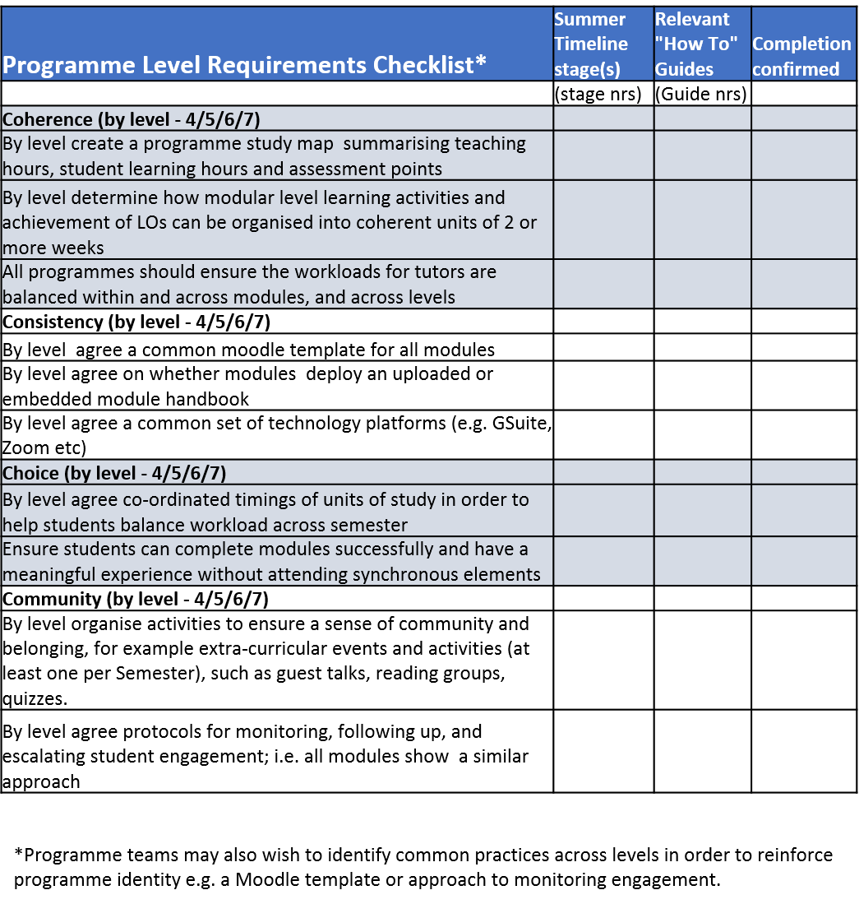

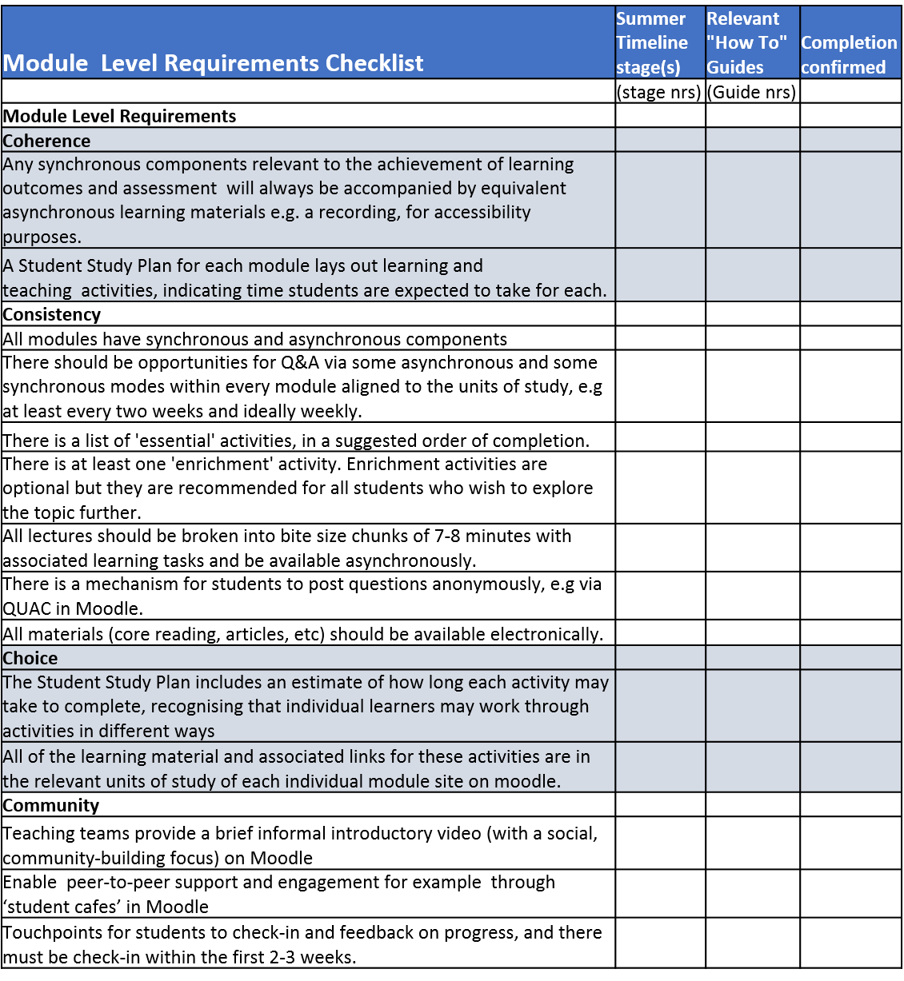

4. Provisional list of “how to” brief guides that will accompany the framework
“The intranet” below refers to the current intranet site: https://intranet.brookes.ac.uk/ocsld/moving-teaching-and-assessment-online-covid19/

No. | Topic | Current status
 | Programme Moodle Template options | Expand examples on intranet
 | The technology platforms available to you | Update intranet
 | How to get the most out of Moodle- series of brief guides  - Using google meet  - Recording powerpoint presentations  - Making a video and uploading it  - Monitoring activity completions and use of progression badges  - Use of registers  - Use of discussion fora  - Use of quizzes  - Integrating moodle and library resources  - Sources of technical support | Existing on intranet  Existing on intranet  To be developed  In development  In development  Existing on intranet  Existing  Existing  Existing on intranet
 | Why we need to think in terms of Units of Study not weeks | To be developed
 | When are synchronous activities appropriate ? | To be developed
 | When are asynchronous sessions appropriate? | To be developed
 | Creating effective synchronous online learning events | To be developed
 | Creating effective asynchronous online learning tasks | To be developed
 | What is meant by Essential and Enrichment tasks | To be developed
 | Why and how equality, diversity and inclusion matter in online learning | Existing internal documents to be distilled
 | Supporting students with ISPs | Update guidance on intranet
 | Why coherence, consistency, choice and community matter in online learning | To be developed
 | How to integrate the Education and Enterprise pillar in the OBU 2035 strategy in your planning | To be developed
 | Moving assessment online | Update guidance on intranet
 | Giving feedback to groups and individuals online | To be developed
 | Moving vivas online | Update guidance on intranet
 | Moving field trips online/managing socially distanced field trips and field work | Update guidance on intranet
 | Staff FAQs on planning for Semester One | Update guidance on intranet
 | Managing lab work online or in socially distanced environments | To be developed
 | Managing placement search and managing placement students | To be developed
 | Managing groupwork online | To be developed
 | Monitoring and following up student participation and engagement | To be developed
 | The role of the Academic Adviser and the use of office hours | Base on existing resources
 | Monitoring student engagement and progress in Moodle | https://telsupport.brookes.ac.uk/tags/completion-tracking/

Working Group Responsible for the development of this Framework

Dominic Corrywright
Irmgard Huppe
Samia Kamal
Krishna Kaur
Diana Limburg
Jenny Lloyd
Jonathan Louw
Andrea Macrae
Jane Pritchard

29.5.20

