Change Checklist
Managers personal change checklist

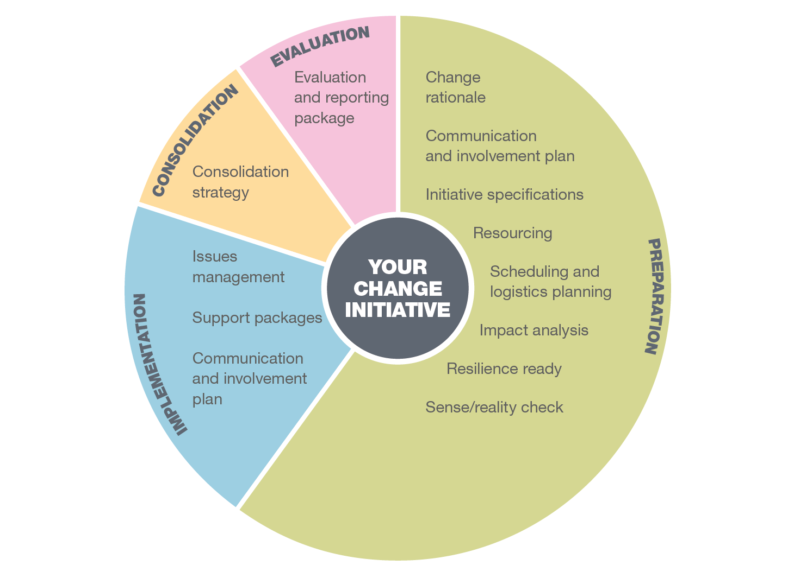
This checklist contains a series of prompt questions and suggestions to aid managers in undertaking a change initiative within their area of the University.

Change initiative

Please note: Large-scale changes and projects should apply a fuller project management approach. Please contact Strategic Change and Projects Governance Team.

An electronic copy of this form can be downloaded from
www.brookes.ac.uk/staff/working-at-brookes/organisational-development/change-support-for-managers

This is a form-fill-activated document. To deactivate the form go to the “Review” tab and select “Restrict Editing” then go to “Stop protection”: the password is password

1 | Rationale for change  Effective change leaders can provide a compelling reason for change.
 |  | Yes | N/A | Notes
Q1:1 | Have you prepared a rationale (need/justification) for the change?
Q1:2 | Have you articulated the benefits this change will bring (or the risks it will mitigate)?
Q1:3 | Is this change in alignment with the Faculty / Directorate or University plans and strategies?
 | Go to: www.brookes.ac.uk/about-brookes/strategy/
Q1:4 | Have you assessed the 'readiness for change' identifying the stakeholders supporting change both within your Faculty / Directorate or beyond?
Q1:5 | Have you proactively identified what resistance (and barriers) to the change might look like?
Q1:6 | Have you completed a Terms of Reference for your change initiative?
 | Go to: www.brookes.ac.uk/staff/working-at-brookes/organisational-development/change-support-for-managers
Q1:7 | Are you able to articulate a sense of urgency (priority) for this change?
Q1:8 | Will your change initiative have staffing implications which require support from your Strategic People Partner
 | Link to People Directorate contacts:
Q1:9 | Your Strategic People Partner is

2 | Communication & involvement  An effective change initiative is usually achieved through a well-considered strategy to communicate and involve all stakeholders impacted.
 |  | Yes | N/A | Notes
Q2:1 | Have you presented your change initiative to your Faculty Executive or Directorate Management Team for awareness, discussion and where necessary approval?
Q2:2 | How have you identified the full range of stakeholders who need to be involved in the change?
Q2:3 | Are you preparing a communication plan?
Q2:4 | Have you prepared a communiqué outlining how you will involve staff / users throughout the change process?
Q2:5 | Will the changes you are considering require formal consultation between the faculty / directorate management teams and recognised staff representatives?
 | go to Employment-policies/unions
Q2:5a | If yes to Q2:5 have you started discussions with the People Directorate on a consultation approach?

3 | Initiative specifications  An outline of the particular needs to be satisfied or essential characteristics that is required (in materials, method, process, service, system, or work).
 |  | Yes | N/A | Notes
Q3:1 | Have you prepared (or scoped) an outline of the requirements/specifications (in materials, method, process, service, system, or work) required for your change initiative?
Q3:2 | Have you considered how you will involve staff/users in developing these requirements/specifications?
Q3:3 | Have you considered using a process review to scope out the requirements for your change?
 | Go to: www.brookes.ac.uk/staff/working-at-brookes/organisational-development/process

4 | Resourcing  Outline, organise and monitor the resourcing required to implement your change.
 |  | Yes | N/A | Notes
Q4:1 | How have you estimated your resource requirements?  Have you shared this with stakeholders?
Q4:2 | Have you estimated staff time requirements required to implement this change?
Q4:3 | Have you considered what additional support will be required from other parts of the University?
Q4:4 | Have you considered the impact on the on-going delivery of business as usual activities as well as individual workloads if you assign existing staff to this change initiative?
Q4:5 | Are you required to evaluate the costs and allocate an approved budget to this initiative?  Cost code is
Q4:6 | Has this been compared to the cost and resource implications if the change is not initiated?

5 | Scheduling and logistics  In its simplest form the setting up of a timetable of when activities are planned together with who is assigned/responsible to carry them out.
 |  | Yes | N/A | Notes
Q5:1 | Have you prepared a timetable for this change initiative?
Q5:2 | Have you checked your time table against key university events and other date dependent initiatives?
Go to: https://www.brookes.ac.uk/about-brookes/semester-dates/
Go to: https://www.brookes.ac.uk/about-brookes/university-calendar
Q5:3 | Does your time table impact on other things happening locally or across the University?
Q5:4 | Have you allowed sufficient time for testing?
Q5:5 | Have you allowed adequate time for contingencies?

6 | Consequential impact analysis  Identifying the potential intended or unintended consequences the change may have on the organisation, staff, students and other stakeholders.  (e.g. in terms of risks, dependencies, assumptions, sustainability, equality & diversity).
 |  | Yes | N/A | Notes
Q6:1 | Have you identified the potential risks to the university associated with implementation of the change?
 | go to: www.brookes.ac.uk/staff/projects/templates-and-guidance-list/
Q6:2 | How will you mitigate against (or reduce) these risks?
Q6:3 | Have you identified (listed) the possible linkages and dependencies associated with your initiative?
Q6.4 | In particular have you fully considered the impacts your change will have on the student experience?
Q6:5 | Have you cross checked with the University Project Registry to identify any projects which may have impacts on your change initiative?
 | Go to: sites.google.com/brookes.ac.uk/psig/home

Q6:6 | Have you considered whether the change will impact on business continuity capability both within your Faculty/Directorate or to the wider University?
Contact your designated person or the Major Incident Manager
Go to www.brookes.ac.uk/fls/bcmip/
Q6:7 | Have you identified any possible sustainability impacts associated with your change initiative?
 | Go to: www.brookes.ac.uk/sustainability/
Q6:8 | Have you identified any possible equality, diversity and inclusion impacts associated with your change initiative?
 | Go to: www.brookes.ac.uk/staff/working-at-brookes/equality-diversity-and-inclusion
Q6:9 | Have you assessed whether this change initiative might positively or negatively impact the University’s reputation?
 | Go to: www.brookes.ac.uk/marketing-recruitment-and-engagement/communications-team/
Q6:10 | Are you basing your change initiative on some key assumptions? Can you articulate those assumptions?  Have you validated those assumptions with those impacted?

7 | Resilience ready  Are you personally prepared to lead and manage this change initiative?
 |  | Yes | N/A | Notes
Q7:1 | Do you personally support the rationale for this change initiative?  (If not can you reconcile yourself to its implementation?)
Q7:2 | Are you set to be a role example in the way you engage with the change?
Q7:3 | Have you allocated yourself sufficient time to support this change initiative?
Q7:4 | Have you considered approaching a trusted colleague to act in a coaching role to support you through this change?
Q7:5 | Have you thought about other support which will help you as you go through the change?
Q7:6 | Have you considered mechanisms to help you switch off and relax when you are away from work?

8 | Sense / reality check (prior to launch)  Applying a common sense rational to commence or delay a change initiative based upon the prevailing conditions within the university (e.g. launching a change during induction week zero).
 |  | Yes | N/A | Notes
Q8:1 | Is a major event or critical incident occurring which evokes a common sense approach to delay the commencement of your change initiative?
Q8:2 | Have you considered what factors you should check prior to the commencing implementation phase?
Q8:3 | Have you considered the implications and communication strategy required if you delay the change implementation?

9 | Support packages  Change implementation is more effective and successful when packages of support are provided to assist people through the change (discuss with your People Directorate Partners).
 |  | Yes | N/A | Notes
Q9:1 | Do you have support packages in place for staff / users / students affected by the change?
Q9:2 | Have you considered the time requirements the team or users will need to allocate to this change and how it will impact on their workload?
Q9:3 | Have you identified training needs to support this change?

10 | Issues management  Implementing a change initiative will often throw up issues which require resolution (often quickly).
 |  | Yes | N/A | Notes
Q10:1 | Have you set up a mechanism to actively manage issues as they arise during the implementation phase?
 | Go to: www.brookes.ac.uk/staff/projects/templates-and-guidance-list/
Q10:2 | Have you set aside time for managing issues?

11 | Communication & involvement (implementation phase)  Effective change management is usually achieved through well-considered communication and involvement with stakeholders.
 |  | Yes | N/A | Notes
Q11:1 | Have you prepared a communiqué in preparation for the implementation phase?
Q11:2 | Are there two way communication channels established to support this change initiative?
Q11:3 | Have you prepared methods for celebrating successes (even small ones) during implementation?

12 | Consolidation  For a change to be successful it should ultimately be viewed by the users as business as usual.
 |  | Yes | N/A | Notes
Q12:1 | Do you have a strategy (or thinking) to consolidate the change post implementation?
Q12:2 | Have you developed systems to monitor and track the adoption of the new solution?
Q12:3 | Do you have mechanisms in place for diagnosing gaps and resistance?

13 | Evaluation and reporting package  Validation that the change has delivered benefits. Lessons learnt for implementing future changes.
 |  | Yes | N/A | Notes
Q13:1 | Have you considered how you will evaluate your change initiative as being a beneficial one?
Q13:2 | Will you allocate time at the end of the change initiative to review what went well and what you have learned for future initiatives?

14 | Notes  What have you identified as the top 3 considerations for your change initiative.  Any other miscellaneous notes for additional prompts and thoughts.

Acknowledgements: This check list was initially compiled in 2015 with inputs from colleagues from across the University. It represents. an amalgamation of learnt experiences in bringing about change within Oxford Brookes.

